**NepaFund Web**

**Hierarchical Task Analysis (HTA)**

HTA for User:

0.0: User.

1.0: Open the landing page

2.0: Register to create an account

3.0: Login

4.0: Homepage  
 4.1.0: Search for project & real estate filter

4.1.1: Get results of searched & filtered projects

4.1.2: Project Details Panel

4.1.2.1: Read the details of the project

4.1.2.2: See the featured images

4.1.2.3: Fill Waitlist Form

5.0: Go to Dashboard

5.1: Check your waitlists  
5.2: View Listings

5.3: List your startups

6.0: Change password

7.0: Logout

Plan:  
plans 1: user must create an account  
plans 2: user must fill valid email 2.1  
  
HTA for Admin

0.0: Go to the Login Panel  
1.0: login as admin  
2.0: Track the data of the contact  
3.0. View the requests for startups and funds  
4.0. Add new project listings

5.0. Check and edit users and realtor data  
5.0. Logout

Plan 1 admin can add other admins and moderators as required  
Plan 4: Admin can delete, edit and add projects

Figure 3

HTA for Signup Page

1.0: To signup click for register on the top navbar

1.1: Insert the username

1.2: Insert valid email address

1.3: Insert user password

1.4: Confirm user password

1.5: Click the register button

Figure 4

## HTA for Admin

## 

Figure 5

**Paper Prototype (Low Fidelity)**

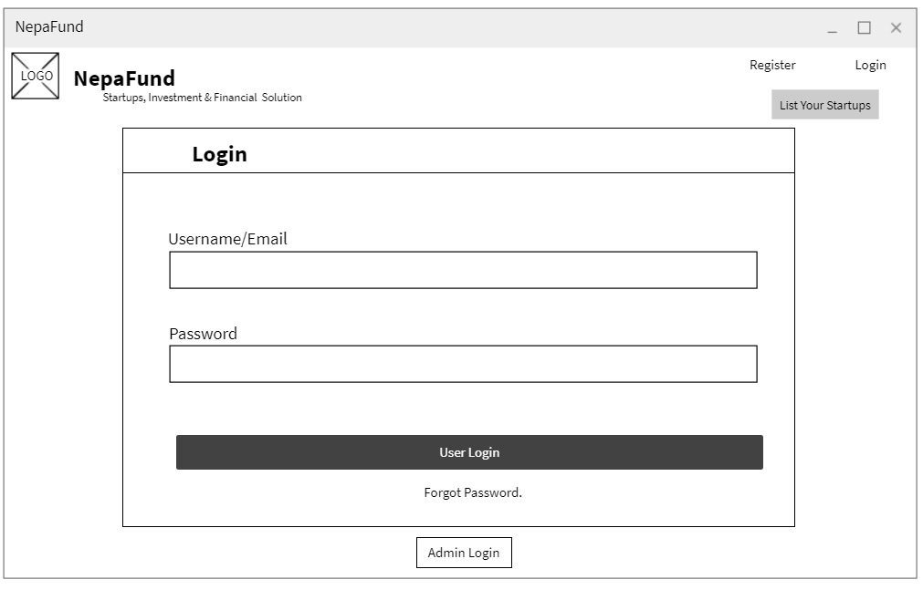

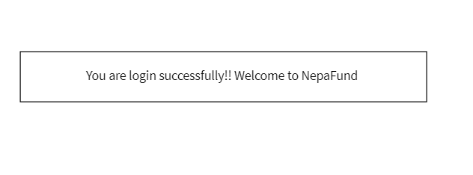Figure 13

Figure 14

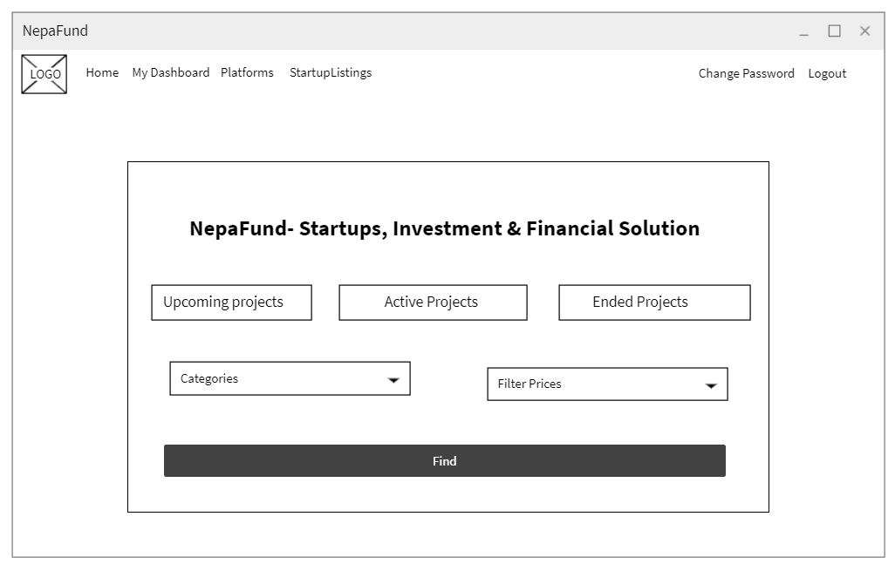

Figure 15

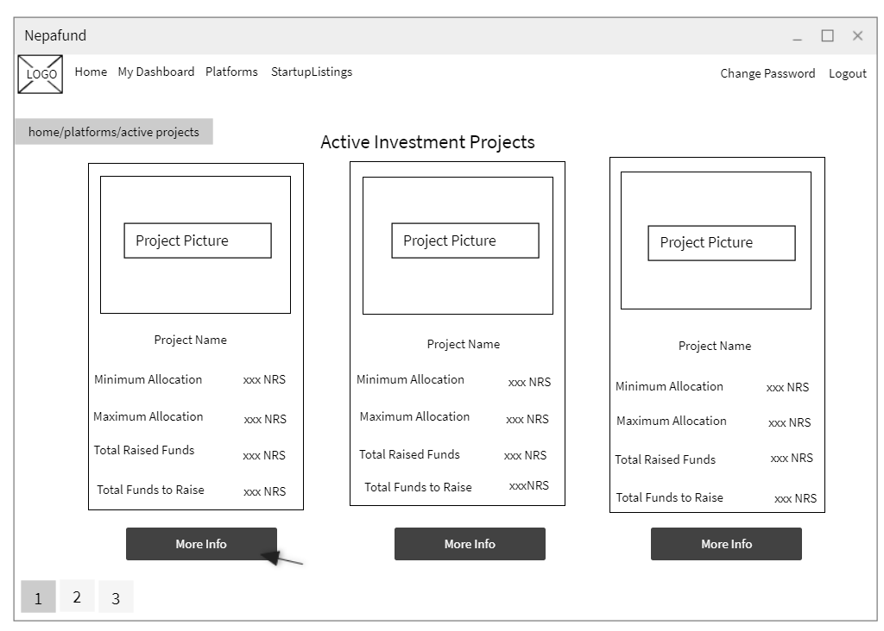

Figure 16

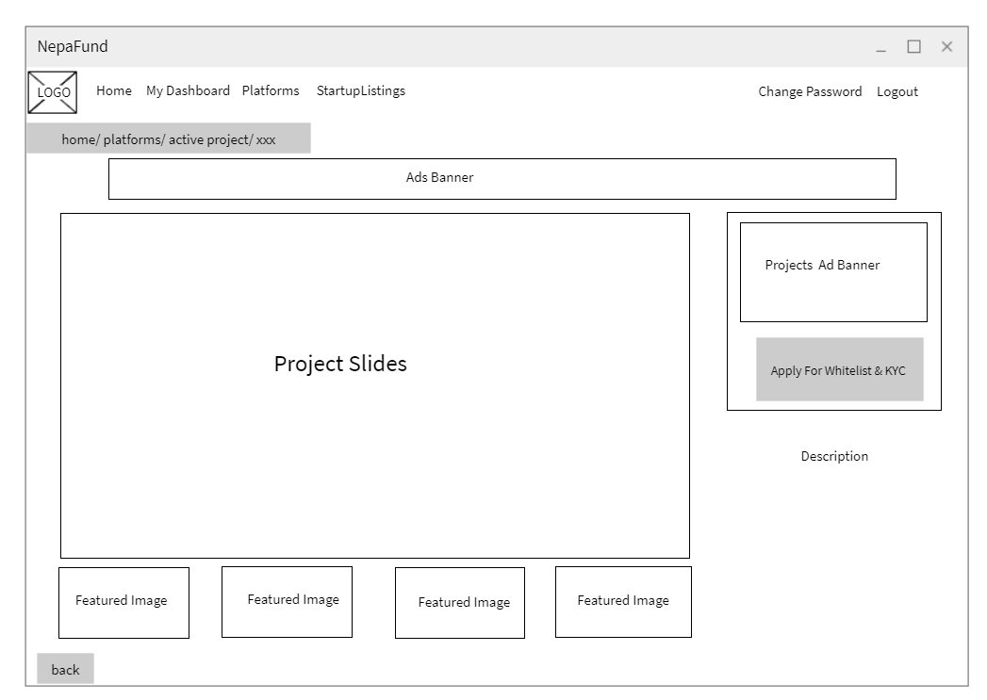

Figure 17

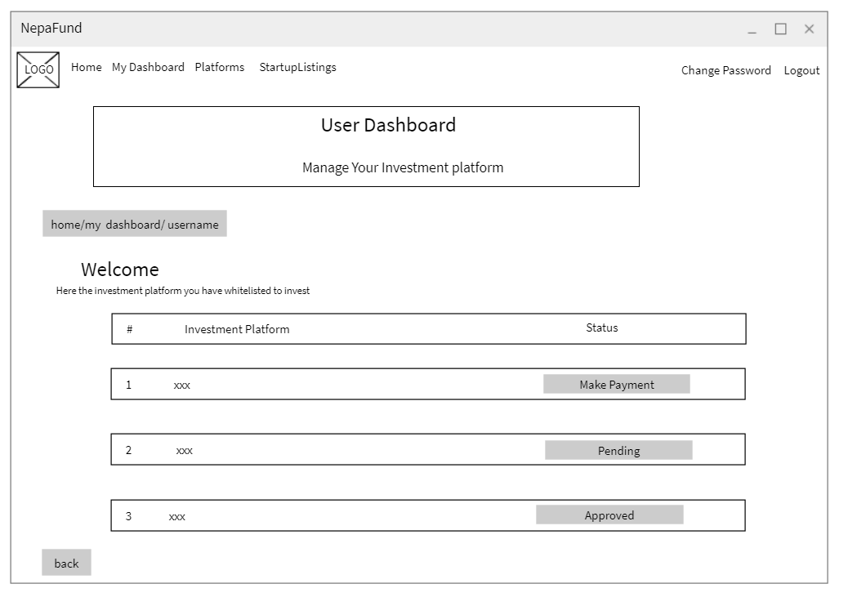

Figure 18

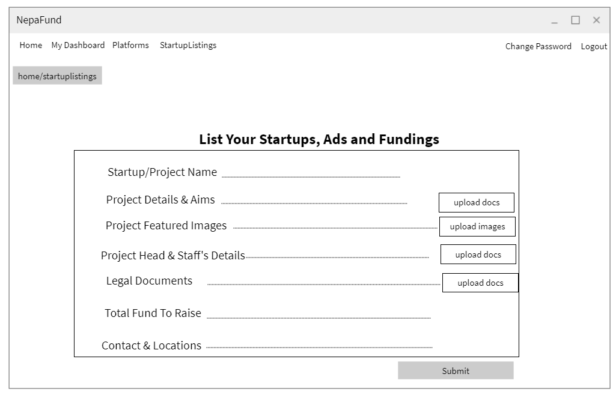

Figure 19



Figure 20

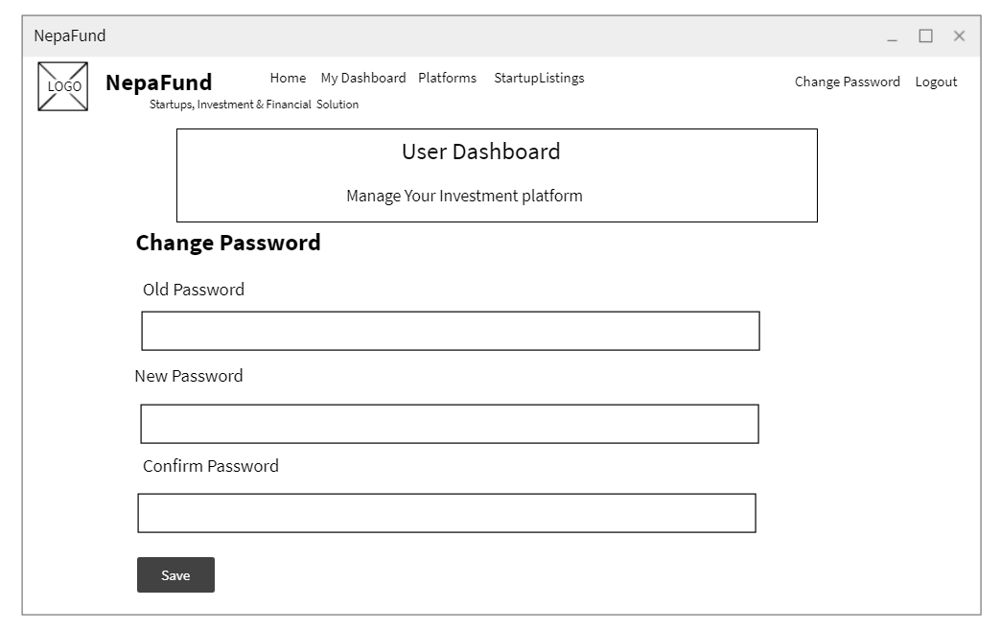

Figure 21

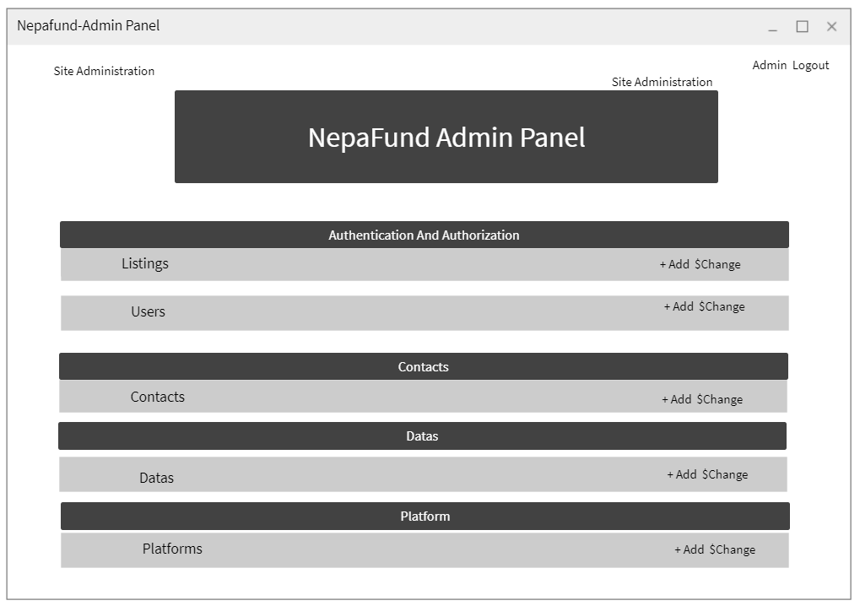

Figure 22

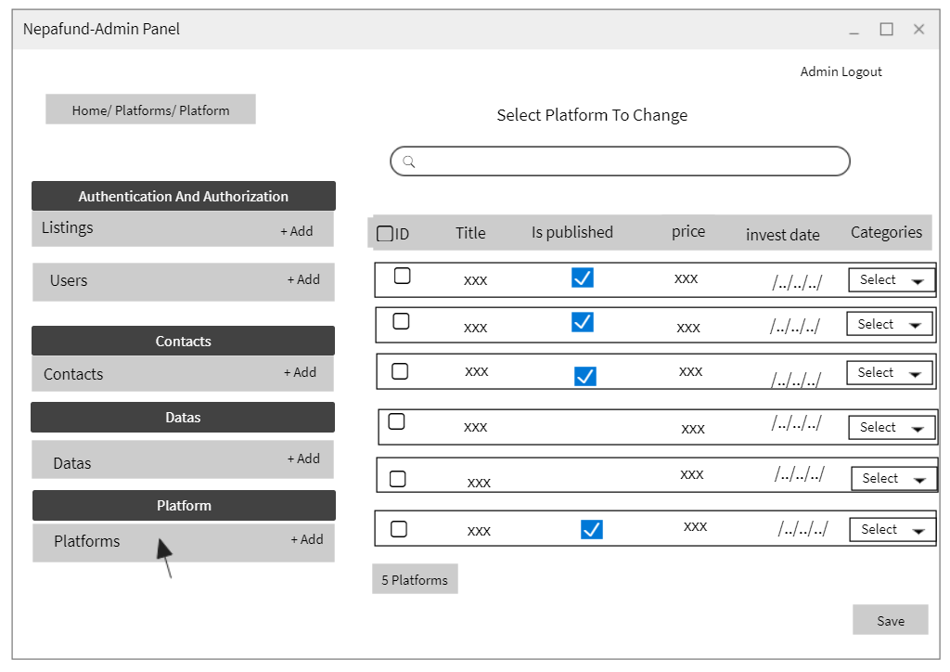

Figure 23

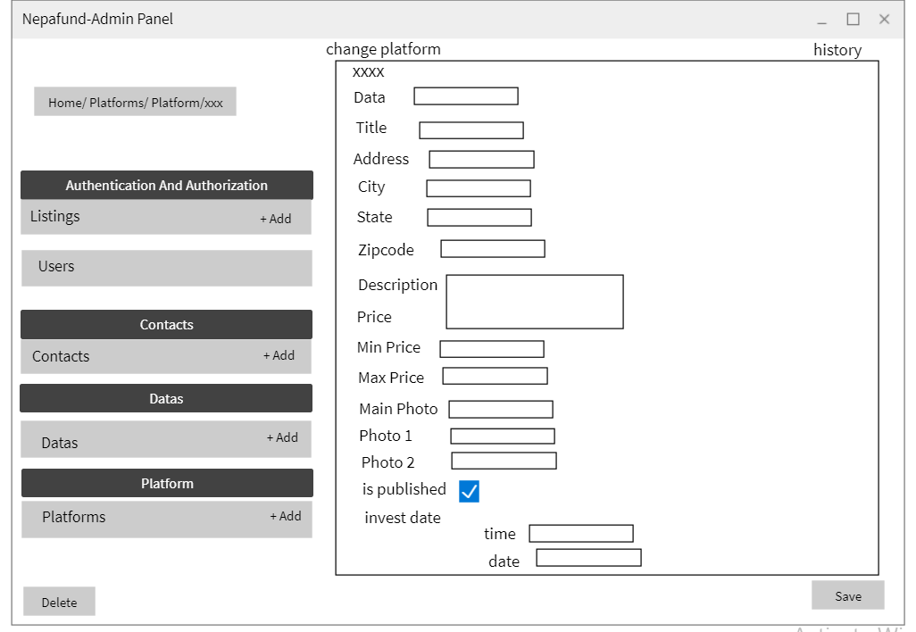

Figure 24

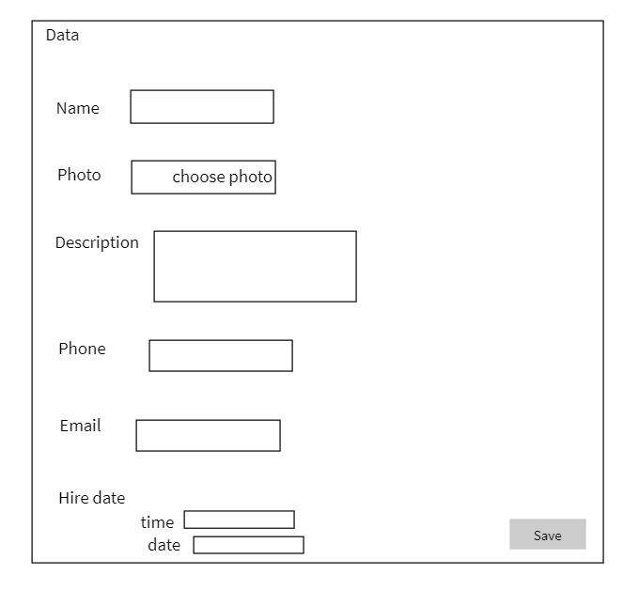

Figure 25

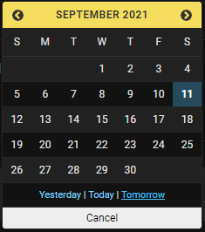

Figure 26

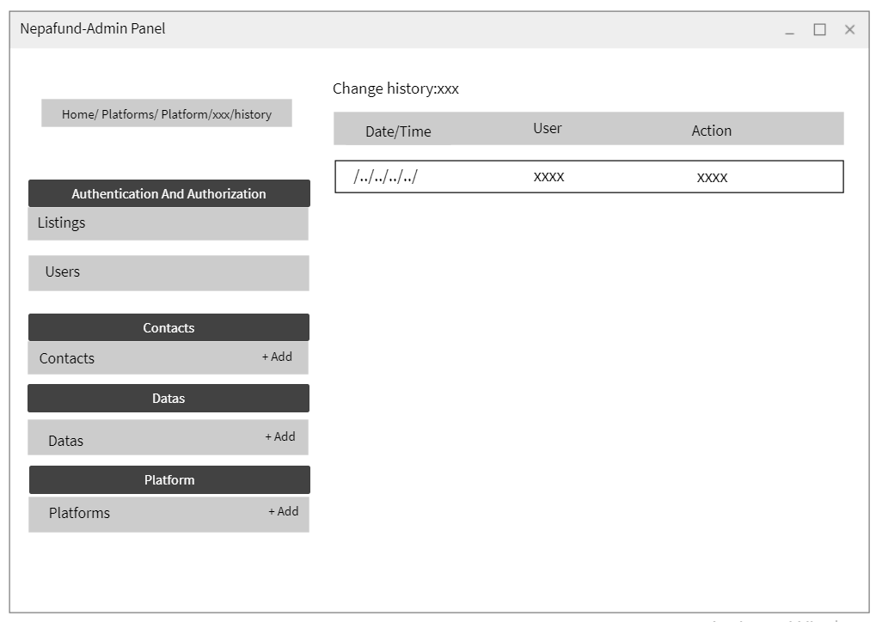

Figure 27

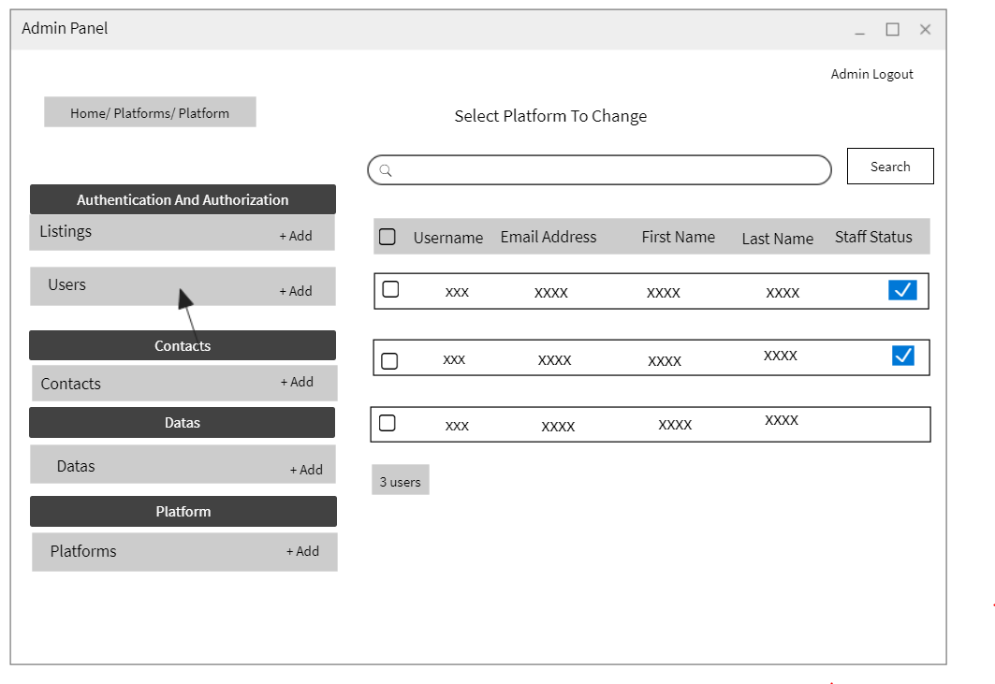

Figure 28

# **DIGITAL PROTOTYPE (High Fidelity)**

